**THE EBRINGTON SITE**

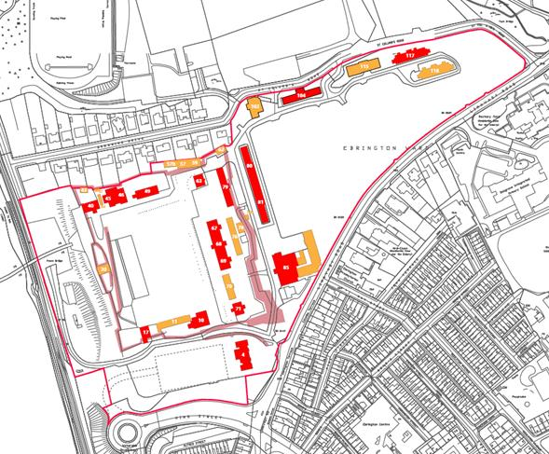

RED

**Listed Buildings**

YELLOW**Retained Buildings**

The Star Fort Wall is a scheduled monument

1. **INFRASTRUCTURE/ENABLING WORKS**

**New Service Roads**

* Service Road behind Building 80/81. Due for completion October 2020.
* Main entrance at Limavady Road – Works complete and road open.

**The Square**

* Significant events area
* Over ground car parks are also utilised for events.

**New Public Realm**

* A new public realm area has been created between buildings 102 and 104 accommodating the Peace PledgeTree which was officially opened in November 2019.

**Services**

* Water supply – Upgrade works both inside and outside the site are currently underway as agreed with NI Water.
* Foul and Storm water upgrade works underway.

**De-contamination**

* Remediation works completed.

**Building Refurbishment**

* Enabling works on-going to several buildings in line with Government Protocol for Listed Buildings.

1. **OCCUPIED BUILDINGS**

**Building 80/81**

**Creative Industries Hub**

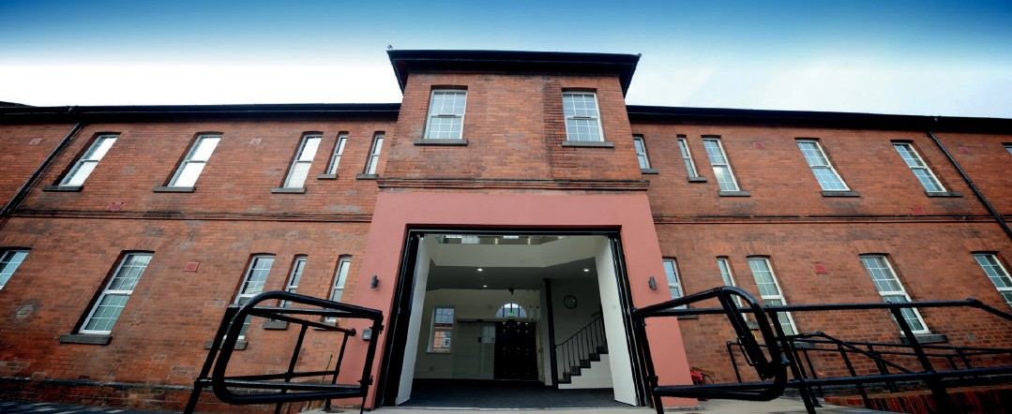

The creative industries provides incubation and follow on space, meeting rooms, communal space to facilitate networking and clustering, and bespoke support programmes for the creative and digital content sectors.

**Buildings 57/59**

**Stables**

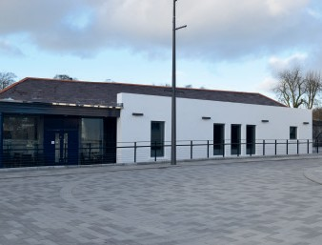

The lease for the premises was recently transferred to a new tenant. The building has been renamed ‘Stables’. Impacted in Q1 by Covid-19 however the building is fully functional in line with social distancing guidelines

**Building 70**

**Walled City Brewery**

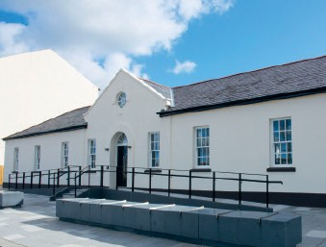

Produces premium quality beer and has an extensive food menu. Its use is restricted at present due to Covid-19 restrictions and the company operates at c70% under social distancing guidelines.

**Building 104**

**Small-medium enterprises**

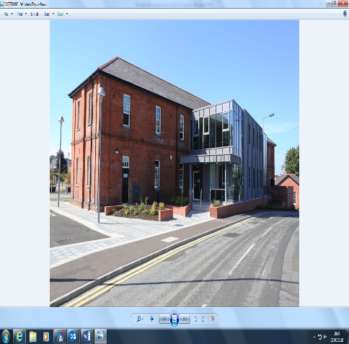

Building 104 was a purpose built accommodation block constructed between 1895 and 1904 and is a listed building. Opened in July 2018 it can accommodate 19 new Small-Medium Enterprise (SMEs) business start-ups, and provide employment opportunities for up to 45 staff. Enterprise North West manage the building under a ten year lease. Building access is restricted at present due to Covid-19 guidelines.

**Building 62**

**Glen Caring**

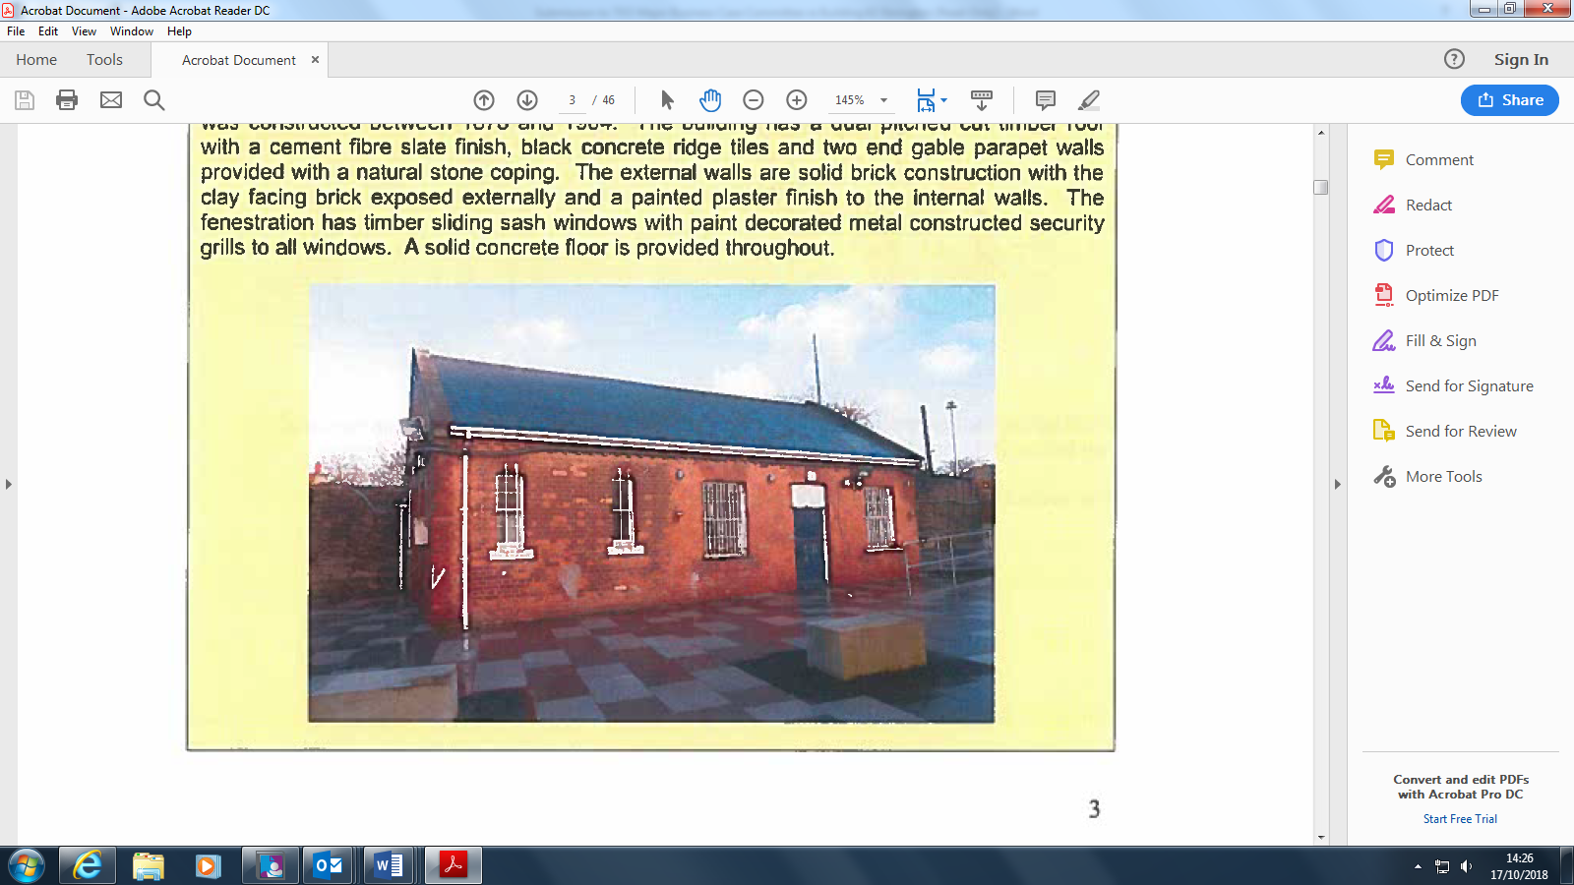

Building 62 was constructed between 1875 and 1904 and opened for business in July 2017 to provide community caring/respite services.

1. **AGREED DEVELOPMENT – IN PROGRESS**

**Grade A Office Accommodation**

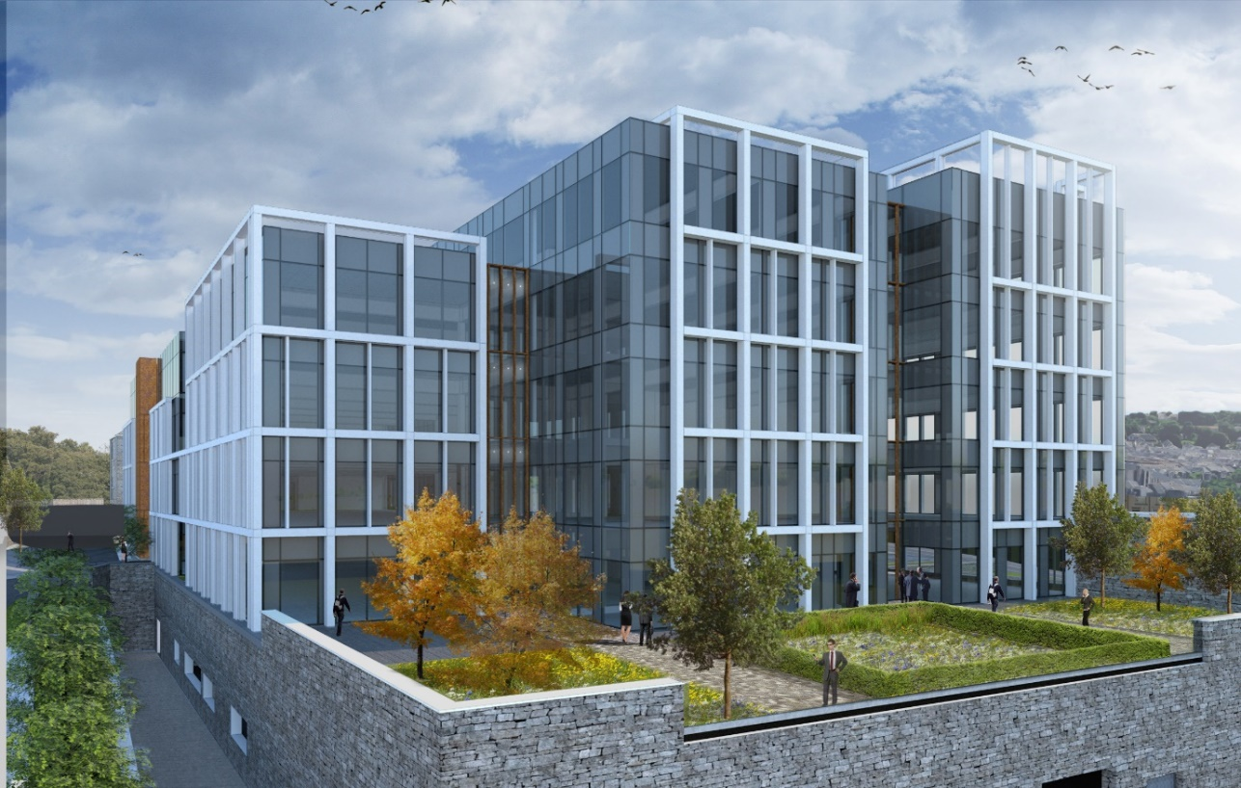

Grade A offices will be built on the Ebrington site providing 62,500 sq² of office space and is due to open in March 2022. It has the potential to accommodate up to 400 staff. The developer Heron Property Limited received planning approval from DfI in September 2019. Construction works started December 2019 but works ceased in March due to the Covid 19. Works restarted in July 2020.

**Building 4**

**Office accommodation**

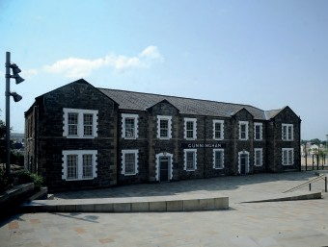

Kevin Watson Group (KWG) has just completed fit-out of the Building to a very high standard commercial office space to accommodate its expanding business. The building opened in February 2020 and staff numbers will build to 35 as soon as possible.

**Building 30**

**Café/Bike Hire**

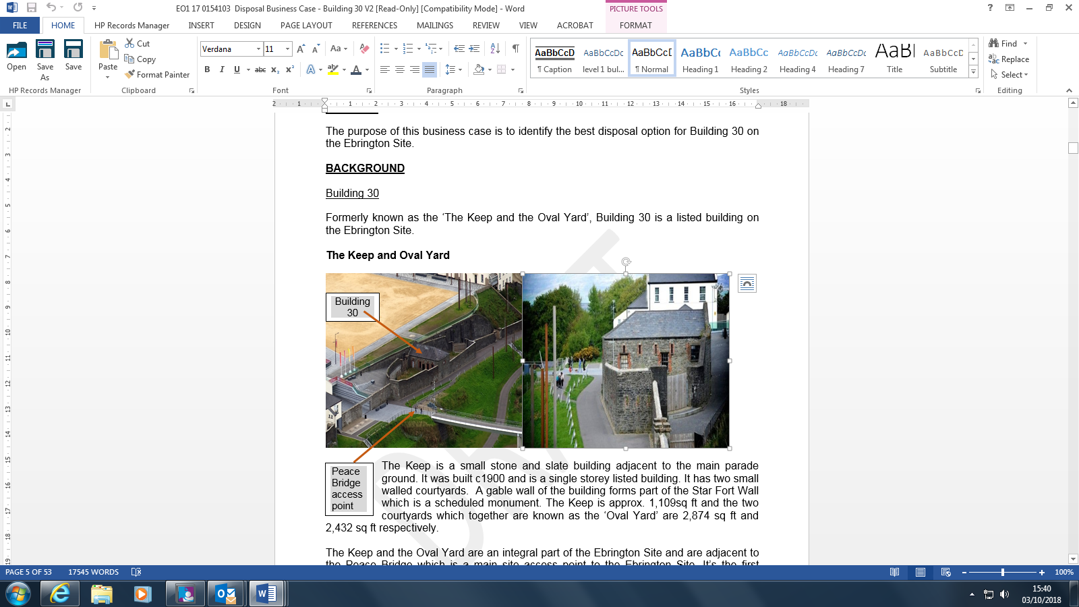

The selected tenant intends to develop Building 30 into a café and bike hire business. Planning and Scheduled Monument Consent approval was received December 2019. Due to delays associated with Covid 19 the tenant now plans to occupy the building by January 2021.

**Building 40**

**Restaurant/Bar**

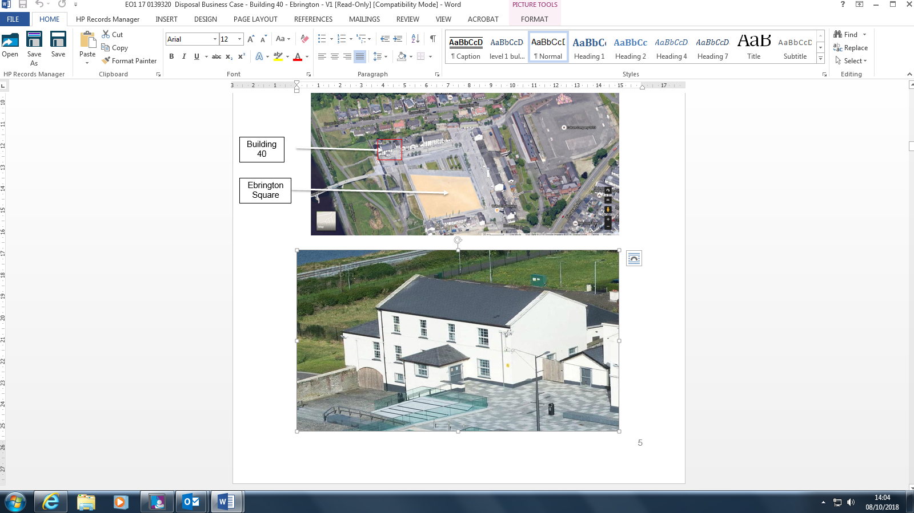

The proposed has sought planning permission to develop Building 40 into a licensed restaurant and bar. Planning to open in spring of 2021 subject to both planning and LBC approval.

**Buildings 63, 67, 68, 69 & 79**

**4-Star Hotel with Spa & Leisure Facilities**

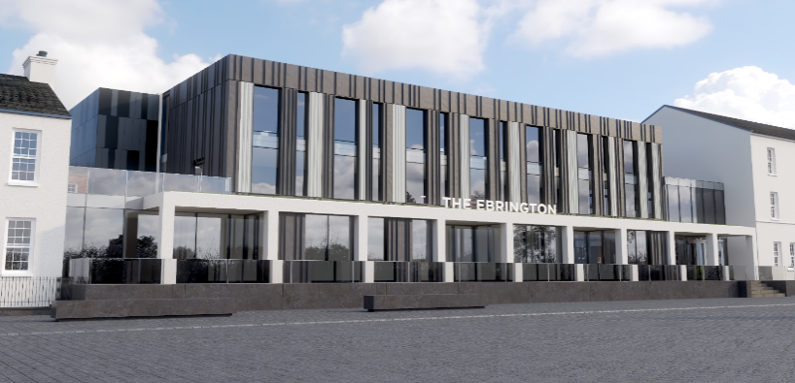

Ebrington Leisure Holdings has achieved planning permission to develop this group of buildings into a 4-star, 152 bed resort hotel with spa and leisure facilities in a two-phased development. Construction was planned to start in May 2020. However construction has been delayed for seven months due to both the health and economic implications of Covid 19. Works are now planned to start in spring 2021.

**Building 102**

**Convenience Store**

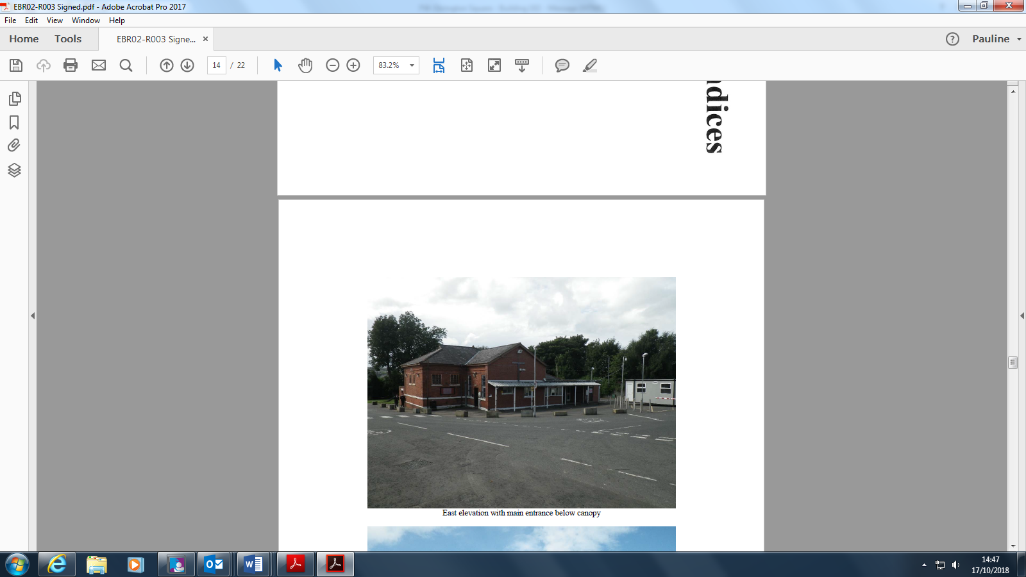

An established retailer has received planning permission to develop this building as a convenience retail store. Legal agreements are complete and works are underway. Planned opening was June 2020 but due to both the health and economic implications of Covid 19 the planned opening date is now early 2021.

**Buildings 83, 85, 117 & 118 + Development Lands**

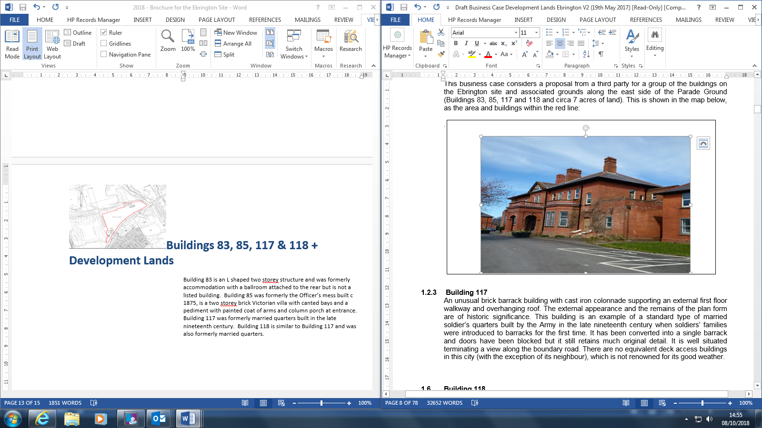

Building 83 is an L shaped two storey former accommodation building with a ballroom attached to the rear. Building 85 was formerly the Officer’s mess built c1875, and is a two storey brick Victorian villa. Buildings 117 and 118 were formerly married quarters built in the late nineteenth century.

A Development Agreement has been signed with Ebrington Holdings Ltd to create mixed uses for the buildings, develop the land and provide car parking in line with the Ebrington Development Framework, subject to phased full planning approvals. The development includes plans for residential, commercial office space, childcare/nursery and art/creative industries. Works to Phase One (Building 83) are nearing completion with the first tenant due to take up occupation in January 2021.

**Buildings 115 & 116**

**Boy & Girl School Houses**

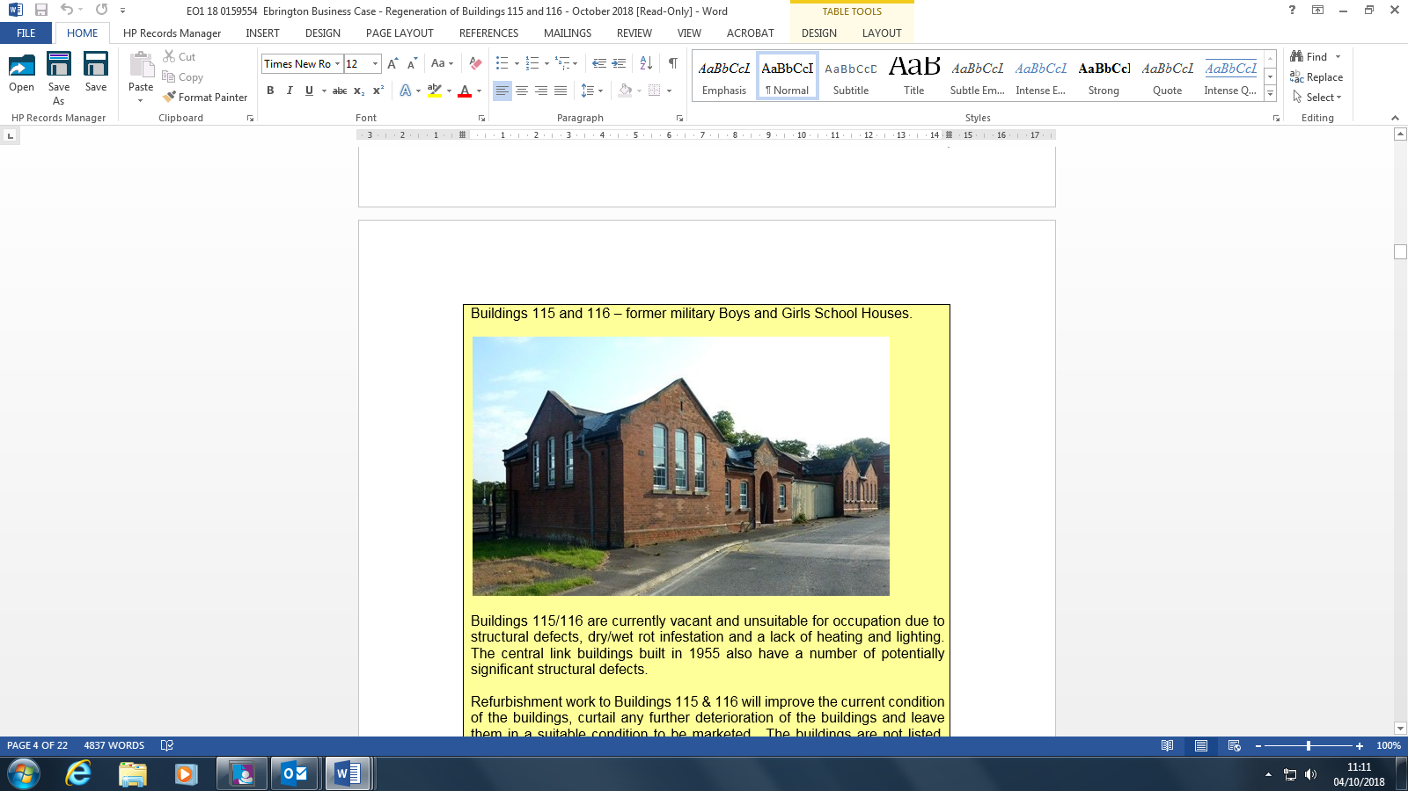

Formerly Buildings 115 and 116 were military boys and girls school houses and joined by a central link built in 1955.

These buildings were offered to the market in April 2019 as two separate buildings and preferred tenants identified. The approvals and legal processes are now complete. Works started in early 2021 and were completed in late July 2020. Both businesses opened in August/September 2020.

**4. Phase 6 Marketing**

**Buildings 10 & 10A**

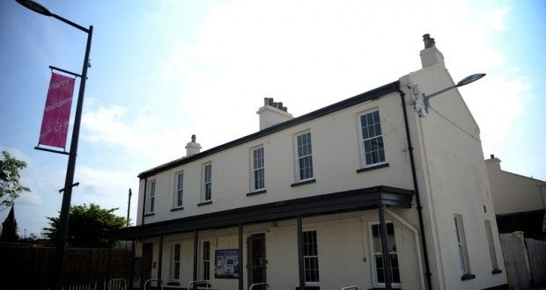

A listed building located on the south side of the 1841 Star Fort, building 10 was the original guard house. This building was offered to the market in June 2019. Tenants have been secured and the approvals process is complete. Legal matters are nearing completion. A planning application will be submitted by August 2020 for Building 10. A planning application has already been submitted for Building 10A.

**Building 11**

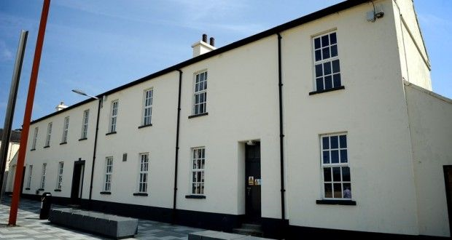

Building 11 overlooks the south side of Ebrington Square and was built in 1841 as a “barrack store”. The building can be extended to the rear and is located beside the underground car park. The foundations of the southern wall of the Star Fort are clearly visible to the rear of Building 11. This building was offered to the market in June 2019. Tenants have been secured and the approvals process is complete. Works are due to start on Phase One refurbishment in October 2020.

**Building 17**

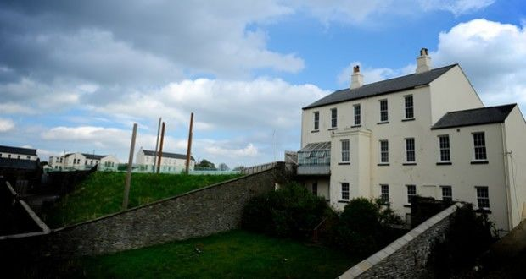

A listed building located on the south side of Ebrington Square overlooking the River Foyle, the Barrack Master’s House has a walled garden within the Star Fort. It has also been known as the Admiral’s House. Conservation and preservation works to the building are ongoing with a view to future marketing.

**5. Maritime Museum Project**

Buildings 45, 46 and 49

The local Council have prepared a business case to redevelop the buildings as Maritime Museum.