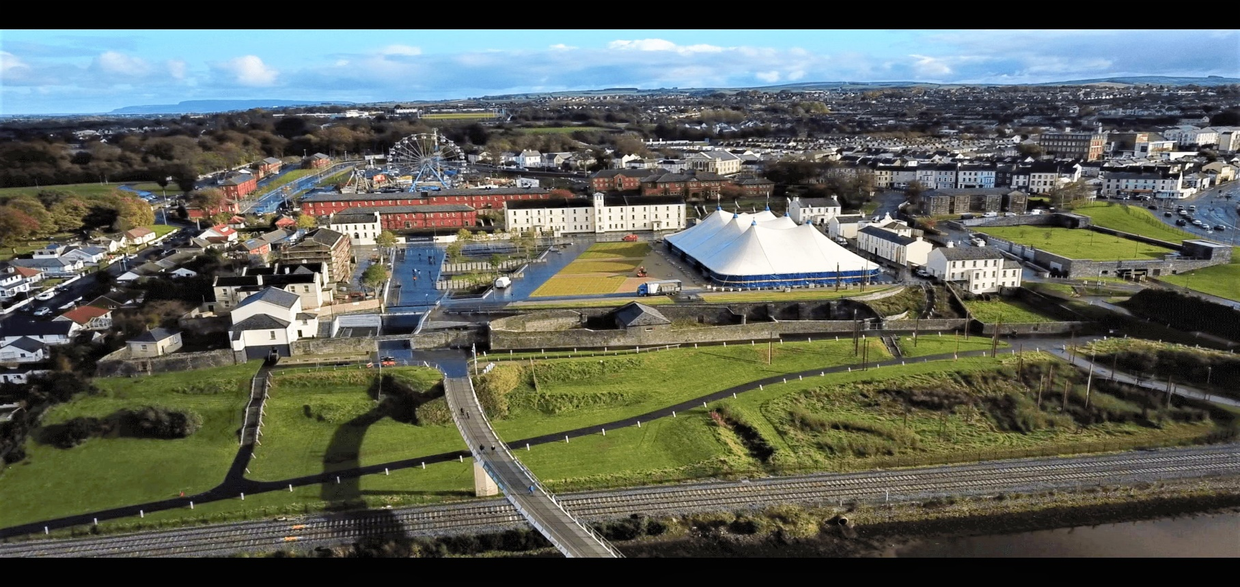

E B R I N G T O N
AND
ST COLUMB’S PARK

www.yourebrington.com
www.derrystrabane.com

Event Space Application 2023 and 2024

1. Applicant details
EBRINGTON/ST. COLUMB’S PARK - EVENT SPACE APPLICATION FORM
Please read the Conditions of Use document before completing this application form.
Please use extra space if required.
Event Promoter (EP)
Name

Organisation/Company Name

Business Address
(including postcode)

Email
Telephone/Mobile
Description of Organisation/Business
(Including registered company no.)

2. Event Details

Name of Event

Preferred Location  (Please Tick)  Select one or more. | Ebrington Square  St. Columb’s Park  (Licensed events only)  Please note TEO/DCSDC will allocate a location
Proposed Event Dates and Times

Is this event? (Please tick)

Commercial Non-commercial Non-Profit Making Other (please detail)

If Charity – Name of Charity:

……………………………………Charity Registration number …………………

Event – Type and Quality of Product - 40%
Please describe your event in full.

Experience and Expertise – 20%
Please detail your experience as an Event Promoter
(CVs and Testimonials of previous events to be included)

Marketing and Communications – 20%
How do you intend to market and publicise the event. Please detail your marketing and Communications budget.

Target Audience and Realistic Expected Attendance – 20%

Please use additional space if required.

Important Note - Both events spaces may not be available on certain days. Please see Conditions of Use before submission of your application.

3. Proposed Occupancy Details

Please provide the following information.
Example
Date | Occupancy type  (please follow example below)
 | Set-up | Event | Decant
01.01.23 | √
02.01.23 |  | √
03.01.23 |  |  | √

Date | Occupancy type  (please follow example below)
 | Set-up | Event | Decant

4. Declaration

In making this application I confirm that:
- The information I have provided in my application is correct and that I am solely responsible for all aspects of the Event.
- All events are run at the Event Promoters’ risk. As EP I will be solely responsible for any and all costs, including fees, even if the event does not proceed.
- I am responsible for supplying all requested information and will liaise directly with the Executive Office and DCSDC on all event related matters.
- I understand that submission of my application does not mean I have permission to hold the event.
- I understand that preference to events supported by DCSDC, Visit Derry, NITB and other Agencies may take precedence and may lead to the cancellation/postponement of events already approved on the Site. Annual events held in previous years in St Columb’s Park will be given priority. Sporting events will also be given priority in St Columb’s park.
- I understand the Executive Office can host five events in total per annum on Ebrington and a range of diverse events is preferred. TEO and DCSDC will select and prioritise events accordingly. Ebrington Square is a premium site.
- I understand that details of my event application, including my contact details, may be provided to other government departments, public bodies, statutory agencies/services, licensing bodies for example for planning, licensing and/or health and safety reasons.
- I will provide evidence that I have booked the Acts listed on my application, at least six months before my event. Failure to do so will result in the opportunity being presented to the next highest scorer.
- I will complete and agree site condition survey(s) and agree to reinstate any damages to their original condition within one week of the event.
- I agree that events must not be publicised and/or advertised before final TEO/DCSDC approval is granted and will share all publicity/marketing before it is made public with TEO and DCSDC.
- I will complete a TEO/DCSDC licence for the event if the event is approved.
- I have read the terms and conditions and agree and agree to provide any additional information that TEO/DCSDC requires.
- I will agree and sign the Event Plan on submission

Agreed, Signed and Dated

Event Promoter Name: ............................................. Date: .....................................

Signature: ……………………………………

Please return your completed application form by return email or the address below no later than 30 November 2022. Late applications will not be accepted.

The Executive Office
Building 71
Ebrington
Derry/Londonderry
BT47 6FA
yourebrington@executiveoffice-ni.gov.uk

This application form provides the Executive Office/DCSDC with an overview of your event only. This is not a booking form, and submitting your application form does not confirm your use of the space requested. No provisional bookings will be made or accepted.

